Supplemental Information

for
Use of High-Order Sensitivity Analysis and Reduced-Form Modeling to Quantify Uncertainty in Particulate Matter Simulations in the Presence of Uncertain Emissions Rates

Wenxian Zhang, Marcus A. Trial, Yongtao Hu, Athanasios Nenes, and Armistead G. Russell

Table S1. Evaluation of CMAQ-simulated concentrations of PM_{2.5} species by comparison with the AQS observational data from August 10 to September 14 in 2006.

PM Species | Number of comparison  pairs | Mean of concentration  (μg m⁻³) | Mean Bias  (μg m⁻³) | Normalized  Mean  Bias (%) | Mean Error  (μg m⁻³) | Normalized  Mean  Error (%) | Mean  Fractional  Bias (%) | Mean  Fractional  Error (%)
PM25_daily | 106 | 15 | -2.5 | -17 | 7.0 | 47 | -30 | 54
SO4_daily | 15 | 5.5 | -2.5 | -46 | 2.6 | 48 | -65 | 66
NO3_daily | 11 | 0.5 | -0.4 | -68 | 0.43 | 79 | -122 | 132
NH4_daily | 15 | 2.4 | -1.2 | -53 | 1.3 | 53 | -59 | 60
EC_daily | 16 | 0.5 | 0.3 | 63 | 0.33 | 66 | 47 | 51
OC_daily | 16 | 3.2 | -1.1 | -35 | 1.6 | 50 | -25 | 54
PM25_hourly | 10710 | 14.2 | -3.6 | -25 | 8.1 | 57 | -40 | 69

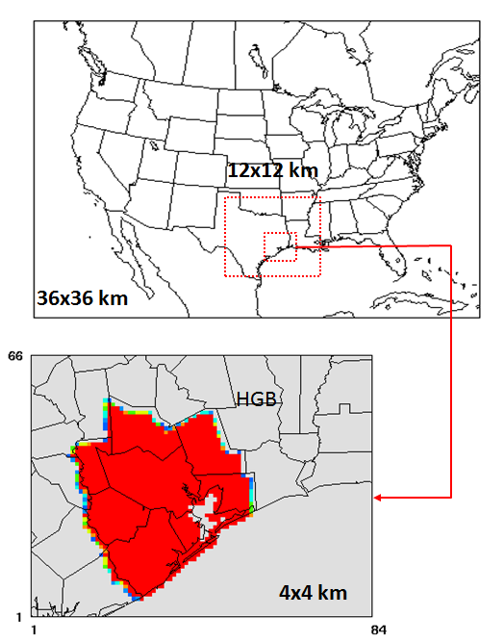
Figure S1. Three nested CMAQ modeling domains including a mother domain with a 36-km horizontal resolution covering the entire continental U.S. and portions of Canada and Mexico, a middle domain with a 12-km horizontal resolution covering eastern Texas and the surrounding states of Oklahoma, Arkansas, and Louisiana, and a inner-most domain with a 4-km grid resolution covering southeastern Texas. The HGB area is highlighted as red.
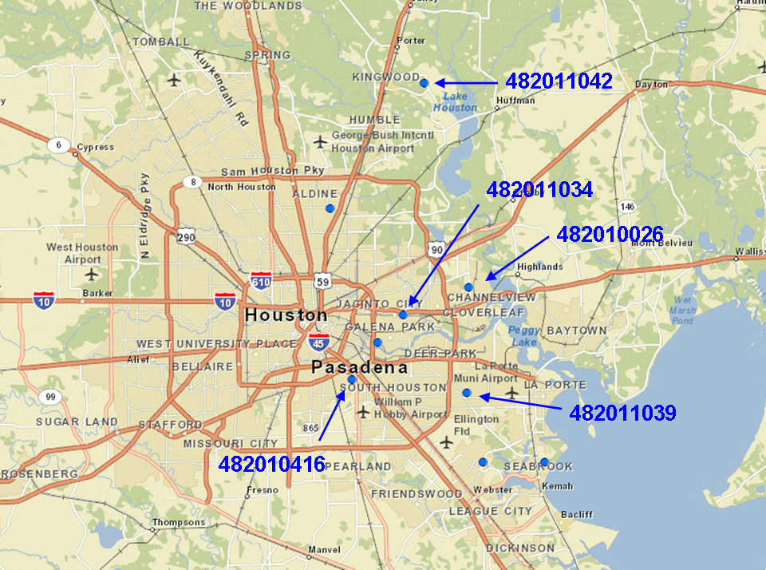
Figure S2. Five AQS monitoring sites selected for comparison with PM_{2.5} simulation. The map is obtained from TCEQ's online map plotting tool Geographical Texas Air Monitoring (GeoTAM, available at http://tceq4apmgwebp1.tceq.texas.gov:8080/geotam/).

Evaluation of RFM and DDM Sensitivities

The RFM is evaluated by comparing the PM_{2.5} concentration simulated by the RFM and the original CMAQ model at 10%, 50%, and 100% reduction in SO₂, NO_{x}, NH₃, and VOC emissions (Figure S3). The field plotted in Figure S3 is daily average PM_{2.5} concentrations at the five monitors used in Figure 5 in the main text. Both the slope of the linear regression and R² is close to one, indicating an excellent agreement between the RFM and the original CMAQ.

First-order DDM sensitivities are evaluated by comparing to brute force (BF) sensitivities calculated using the following methods:
- Forward finite difference (FD) (Eq. S1) with 50% perturbation in emissions,
$S_{BF}^{(1)}=\frac{C_{E+∆E}-C_{E}}{∆E}$ (S1)
- Central FD (Eq. S2) with 50% perturbation in emissions,
$S_{BF}^{(1)}=\frac{C_{E+∆E}-C_{E-∆E}}{2×∆E}$ (S2)
- Backward FD (Eq. S3) with 50% perturbation in emissions, and
$S_{BF}^{(1)}=\frac{C_{E}-C_{E-∆E}}{∆E}$ (S3)
- Central FD (Eq. S2) with 10% perturbation in emissions.

Figure S4 shows the comparison of daily averaged first-order sensitivities to SO₂, NO_{x}, NH₃, and VOC at the five monitors calculated by CMAQ-HDDM and the above four BF methods. Inconsistency was found for BF sensitivities, so cautions should be taken when evaluating the DDM sensitivities with the BF ones. First-order BF sensitivities calculated by forward, backward, and central FD show inconsistency for $\frac{∂{PM}_{2.5}}{∂{NH}_{3}}$, $\frac{∂{PM}_{2.5}}{∂{NO}_{x}}$, and$\frac{∂{PM}_{2.5}}{∂VOC}$. DDM sensitivities turn out to be consistent with one or two of the BF sensitivities. For example, $\frac{∂{PM}_{2.5}}{∂{NH}_{3}}$ calculated by DDM is closer to the value calculated by backward FD; $\frac{∂{PM}_{2.5}}{∂VOC}$ calculated by DDM is closer to the value calculated by forward BF. The perturbation size appears not impact the BF first-order sensitivity to a large extent except BF sensitivity of PM_{2.5} to VOC. Changing the perturbation size from 50% to 10% ended up a six time difference of the BF sensitivities calculated by central FD.

Second-order DDM sensitivities of PM_{2.5} to SO₂, NO_{x}, NH₃, and VOC at the five monitors are also compared to BF values. However, second-order BF sensitivities are even noisy. Central FD of second-order sensitivities (Eq. S4) with emission perturbation of 10% and 50% are compared in Figure S5, and no consistency can be found between the two BF sensitivities. This shows the highly noisy behavior of BF method to approximate the high-order sensitivity, and also it is unknown which BF sensitivity is closer to the true value. Thus, the comparison of second-order DDM sensitivities with BF sensitivities seems not a good way to evaluate CMAQ DDM sensitivities. However, given the good performance of DDM in predicting second-order sensitivities in the stand-alone ISORROPIA (which has less noise in BF second-order sensitivities than CMAQ) (Zhang et al., 2012), and that the good performance of RFM shown in Figure S3, DDM is more likely to provide reliable second-order sensitivities than BF.

$S_{BF}^{(2)}=\frac{C_{E+∆E}-2C_{E}-C_{E-∆E}}{{∆E}^{2}}$ (S4)

The first-order sensitivities of PM_{2.5} to SO₂ calculated by the RFM and the original CMAQ model were also compared using the following emission changes:
a) +50% NO_{x}, +50% NH₃
b) +50% NO_{x}, -50% NH₃
c) -50% NO_{x}, -50% NH₃
d) -50% NO_{x}, +50% NH₃
Figure S6 shows excellent agreement between the RFM and original CMAQ and demonstrated the ability of the RFM to replicate the original model with multiple simultaneous large emission changes.
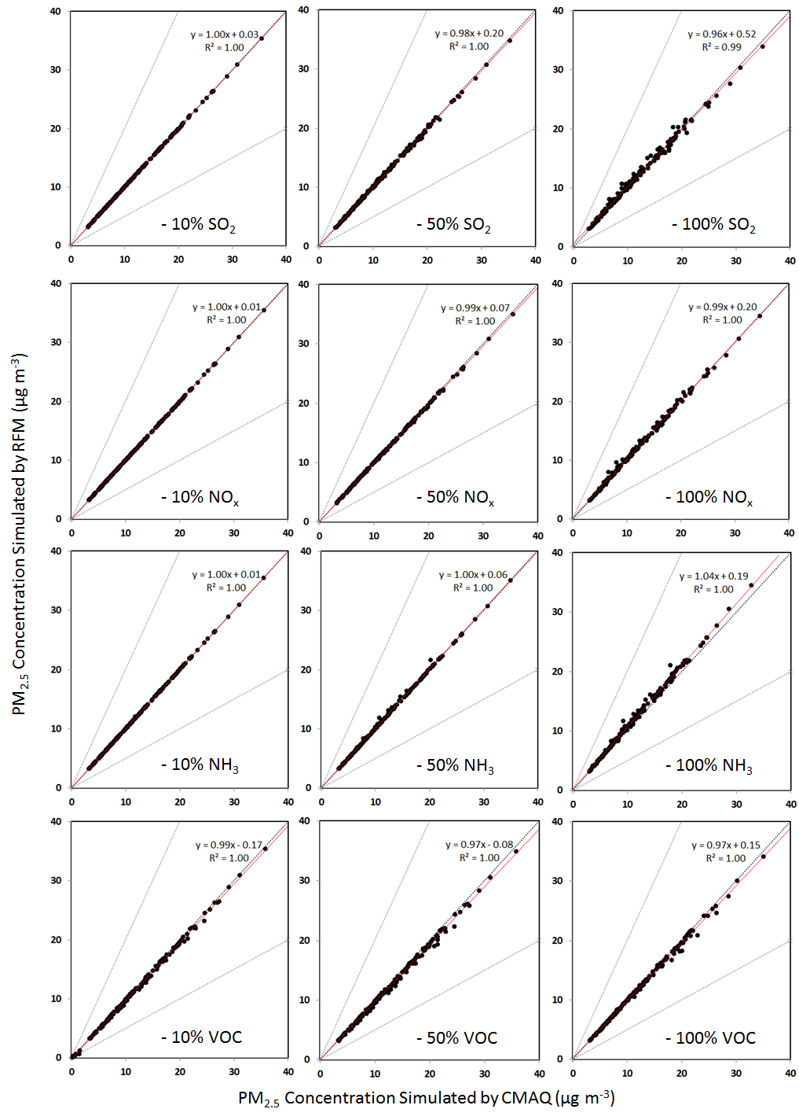
Figure S3. Comparison of PM2.5 concentrations simulated by the original CMAQ and the RFM with 10%, 50%, and 100% reduction in SO2, NOx, NH3, and VOC emissions. The upper, middle and lower grey lines represent 2:1, and 1:1, and 1:2 lines. The red line represents the linear regression of the RFM output against CMAQ simulation.
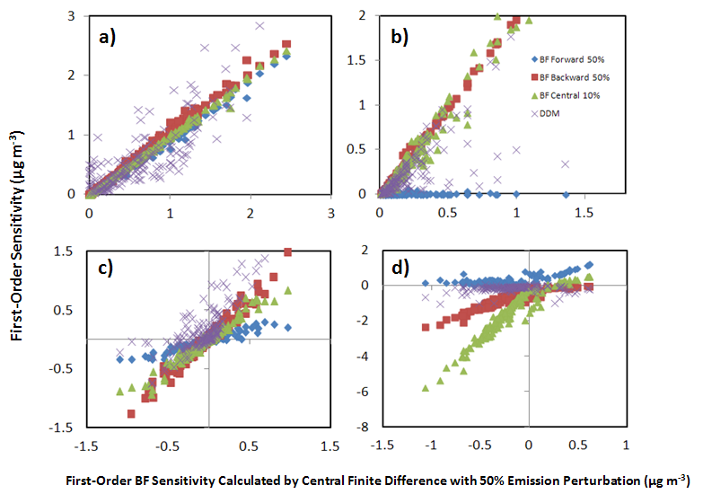
Figure S4. Comparison of First-Order DDM sensitivities (purple cross) with BF sensitivities calculated using central finite difference (FD) with 50% perturbation (used as x-axis), forward FD with 50% perturbation (blue diamond), backward FD with 50% perturbation (red square), and central FD with 10% perturbation (green triangle). The four sensitivities plotted in this figure are a) $\frac{∂{PM}_{2.5}}{∂{SO}_{2}}$, b) $\frac{∂{PM}_{2.5}}{∂{NH}_{3}}$, c) $\frac{∂{PM}_{2.5}}{∂{NO}_{x}}$, d)$\frac{∂{PM}_{2.5}}{∂VOC}$.

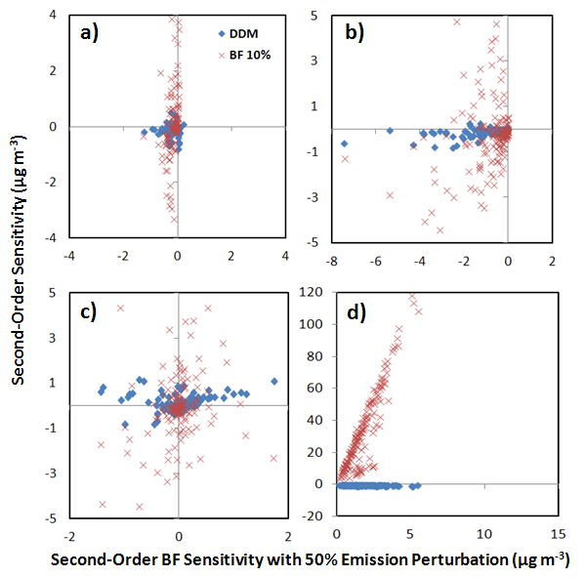
Figure S5. Comparison of Second-Order DDM sensitivities (blue diamond) with BF sensitivities calculated using central finite difference (FD) with 50% (used as x-axis) and 10% (red cross) perturbation. The four sensitivities plotted in this figure are a) $\frac{{∂^{2}PM}_{2.5}}{∂{SO}_{2}^{2}}$, b) $\frac{{∂^{2}PM}_{2.5}}{∂{NH}_{3}^{2}}$, c) $\frac{{∂^{2}PM}_{2.5}}{∂{NO}_{3}^{2}}$, d) $\frac{{∂^{2}PM}_{2.5}}{∂{VOC}^{2}}$.

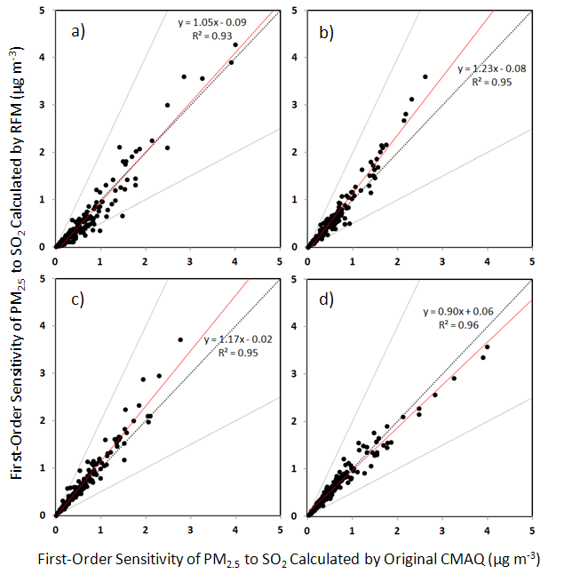
Figure S6. Comparison of $\frac{∂{PM}_{2.5}}{∂{SO}_{2}}$ calculated by the RFM with the original CMAQ model with emission changes of a) +50% NO_{x} and +50% NH₃, b) +50% NO_{x} and -50% NH₃, b) -50% NO_{x} and -50% NH₃, b) -50% NO_{x} and +50% NH₃. The grey lines are the 1:2 and 2:1 lines. The black dotted line is the 1:1 line. The red line represents the linear regression of the RFM output against CMAQ simulations.

